PLEASE JOIN ME FOR A VERY SPECIAL EVENING

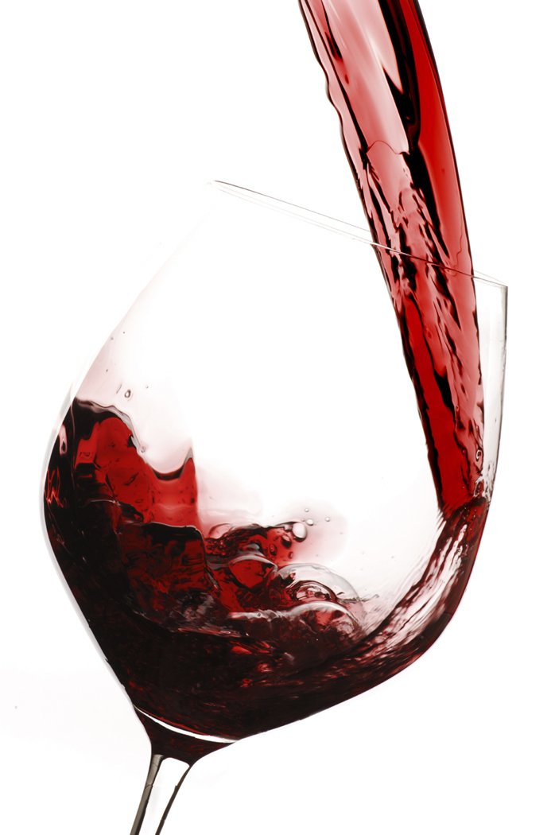 | 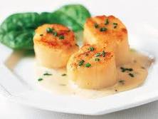 | 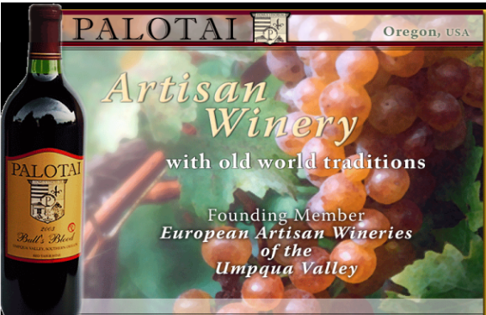

Menu and wine pairing

Homemade Mozzarella Cheese with Italian Spices Olive Oil and Rice Vinegar, Tempura Caper Berries |  | Palotai Dolcetto
Scallops in Lemon Butter Caper Sauce with Asparagus |  | Palotai Chardonnay
Salmon in Puff Pastry and Salmon Wontons in Dill Sauce. Baby arugula salad with pine nuts and balsamic vinaigrette. |  | Lost Coast Pale Fire Pinot
Rack of Lamb Roasted in Cranberry Crunch Mustard, Puree of Celery Root and Carrots |  | Palotai Bulls Blood
Tiramisu |  | Girardet Frostbite

These are some of my favorite tapas dishes and wines. I would love to share them with you. I am limiting this celebration to 8 special people and hope you will be one of them. Please let me know ASAP if you and a guest will be attending so I can plan appropriately.
Looking forward to seeing you and introducing you to these exceptional wines.
Craig Carothers

